

Lower Heath CE Primary School
Cycle A – KS1 – Spring Term

Curious Quest | Maths | Geography | History
  We will continue on our writing quest. With a weekly book to guide our writing, we will crack codes, invent and delve into writing. We invent in COOL time to light up the pathways and use our writing skills to overcome the obstacles that we meet along the way. | In Year 1 we will:  - Name and recognise the properties of 2D and 3D shapes.  - Explore numbers to 20.  - Add and subtract within 20.  - Explore numbers to 50.  - Introduce length and height  - Introduce mass and capacity.  In Year 2 we will cover:  - Properties of shapes.  - Money  - Multiplication and division  - Length and height  - Mass, capacity and temperature | What is the weather like in the UK?  - Name and locate the four countries on a map of the UK.  - Identify the country they live in.  - Identify the four seasons.  - Describe some seasonal changes.  - Identify the four compass directions.  - Use the compass directions to describe the location of features.  - Observe and describe daily weather patterns.  - Begin to locate the four capital cities of the UK.  - Explain what the weather is like during each season in the UK.  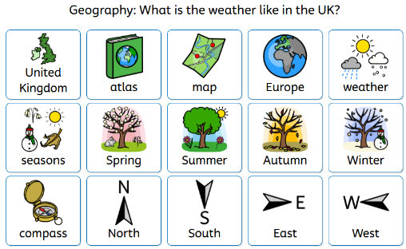  - Suggest appropriate clothing and activities for each season. | How have toys changed?  - Discuss favourite toys using language related to the past.  - Ask questions about toys in the past.  - Make comparisons between toys in the past and present.  - Sequence artefacts from different periods of time.  - Identify changes between teddy bears today and those from 100 years ago.  - Describe how toys have changed over time.  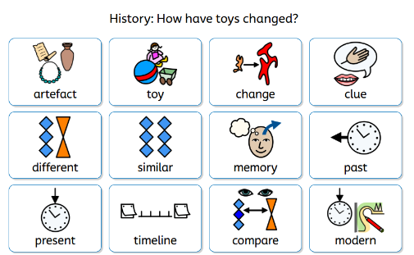
Science | RE | PSHE/RSE | Art
Living things: Habitats  - Recall some life processes, giving examples of how they apply to plants and animals.  - Match different plants and animals to their habitats.  - Give examples of how animals use their habitat for food and shelter.  - Recall that plants produce their own food for energy.  - Name living things that are producers and place a producer at the beginning of a food chain.  - Use arrows to show the order in a food chain.  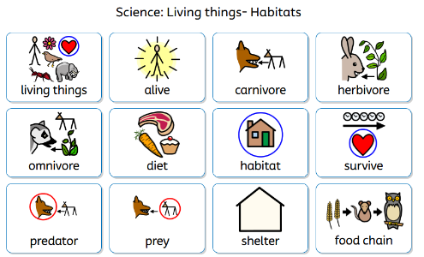  - Identify stages in the life cycles of different animals, including humans.  - Describe the basic survival needs of animals.  - Explain how to take care of personal hygiene.  - Describe some positive effects of exercise.  - Identify foods in different food groups.  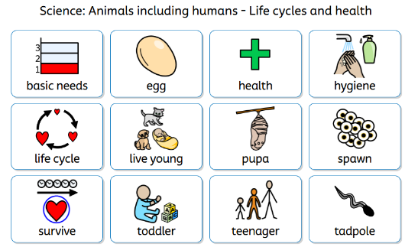 | Why should we care for the world?  - Explain different beliefs about who owns the world.  - Recognise the belief that humans were created last for a reason.  - Recognise why only humans can care for the world.  - Identify the belief that God created humans as stewards over nature through scripture.  - Recognise what some stories about Muhammad tell us about looking after the world.  - Express why stewardship is important to some Muslim people.  - Identify why people who believe in ahimsa may think it is important to look after all living creatures.  - Identify reasons why it is important to care for the world.  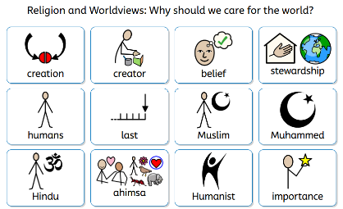  Why do we need to give thanks?  - Identify reasons people may feel thankful and how this is expressed.  - Explain how some people celebrate harvest time.  - Identify the meaning behind some harvest celebrations and practices.  - Talk about what Hindu and Christian followers might learn from stories about gratitude.  - Explain how some Hindus and Christians show their gratitude to God.  - Explain how Hindu worship may reflect a person’s beliefs about gratitude to God.  - Recognise how worship through songs can be used to express thanks to God.  - Express ideas about gratitude using music.  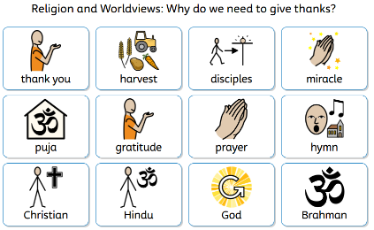 | Health and Wellbeing:  - Describe how they feel using appropriate vocabulary, recognising what different emotions might look/feel like.  - Describe situations which may provoke certain feelings.  - Describe their own qualities and strengths and recognise something they want to get better at.  - Describe their bedtime routine, explaining why sleep is important.  - Explain how rest and relaxation affects our bodies, including mental functions.  - Identify examples where they could use relaxation to help manage difficult emotions.  - Understand that germs can be spread via our hands.  - Know how to wash their hands properly.  - Know the three things they need to do when out in the sun to keep safe.  - Know people can be allergic to certain things and how to help with an allergic reaction.  - Understand that there are a range of people who help to keep us healthy.  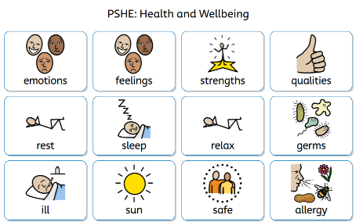  Economic Wellbeing  - Explain how children might get money.  - Explain some different ways to keep money safe.  - Discuss the role of banks and building societies.  - Recognise that people may make different choices about spending or saving.  - Explain that a range of jobs exist in and out of school and that different skills are needed for jobs.  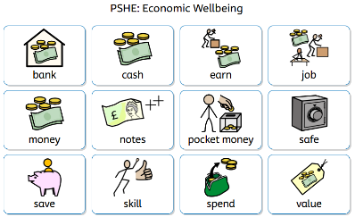 | Sculpture and 3D: Paper Play  - Roll paper tubes and attach them to a base securely.  - Make choices about their sculpture, e.g. how they arrange the tubes on the base or the colours they place next to each other.  - Shape paper strips in a variety of ways to make 3D drawings.  - Glue their strips to a base in an interesting arrangement, overlapping some strips to add interest.  - Create a tree of life sculpture that includes several different techniques for shaping paper.  - Considered how to add detail by adding pattern or decoration to their paper shapes.  - Work successfully with others, sustaining effort over time.  - Explore different tools to paint a sculpture for good coverage and to create a metal surface effect.  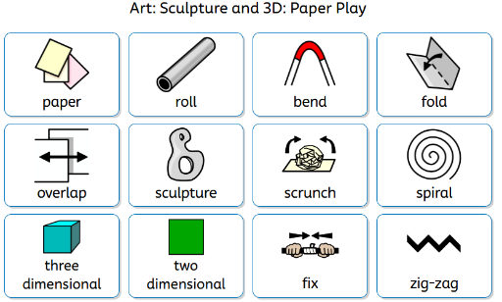
D&T | Music | Computing | PE
Textiles: Simple Stitches  - Name some objects made of fabric.  - Describe the look and feel of different fabrics.  - Thread a needle.  - Make a series of stitches that match each other in embroidery fabric.  - Choose colours and shapes for a design.  - Explain their ideas to others verbally and with a sketch.  - Choose materials based on their texture.  - Follow the general position of the lines of a design with stitches.  - Say what they like about someone else’s stitching and what could be made better.  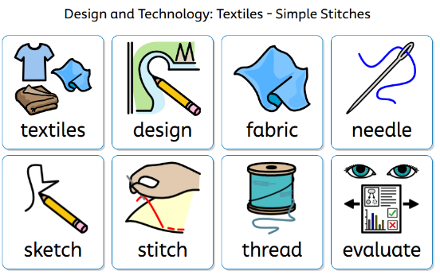 | Pitch: Superheroes  - Identify high and low notes.  - Perform high and low notes.  - Create and perform a two-note and three-note pattern.  - Identify and perform changes in tempo.  - Contribute musical ideas and cooperate within a group.  - Prepare and perform a musical piece.  - Demonstrate a musical understanding of tempo and pitch.  - Participate in discussions about pitch and tempo.  - Offer feedback to groups on their performance.  - Follow instructions during a performance.  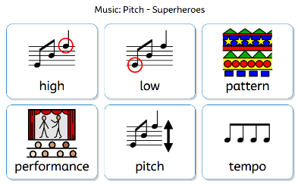  Instruments: Musical storytelling  - Identify sections of the music where the tempo changes.  - Correctly describe sections of music as fast or slow.  - Point out moments in the music where the dynamics change.  - Accurately describe dynamic changes as soft or loud.  - Give specific examples of how the music corresponds to actions in the story.  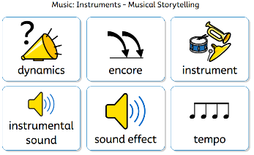 | Online Safety Lesson 3: Always be kind and considerate  - To recognise how to treat others, both online and in person  Skills Showcase: Rocket to the Moon  - Use a computer to make a list.  - Explain the benefits of making a list on the computer.  - Use a basic range of tools on art software to design a rocket.  - Sequence instructions.  - Follow instructions to build their model rocket.  - Evaluate and edit their rocket design.  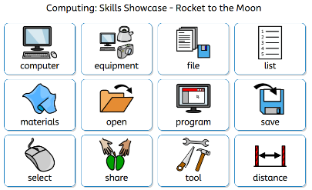  What is a computer?  - Name some computer peripherals and their functions.  - Recognise that buttons cause effects.  - Explain that technology follows instructions.  - Recognise different forms of technology.  - Design an invention which includes inputs and outputs.  - Explain the role of computers in the world around them.  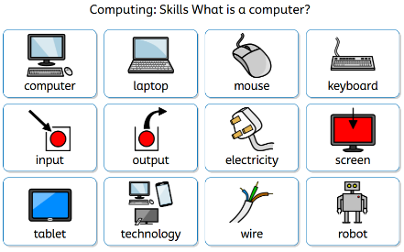 | Moves Programme  This Spring Term, our PE lessons will be concentrating on the MOVE programme, which is designed to help children develop essential physical and social skills. MOVE supports growth in gross and fine motor skills, helping children improve their movement control, balance, and coordination. It also encourages spatial awareness, organisation, and social interaction, giving pupils the confidence to participate actively and work together. Through fun, structured activities, we aim to build strong foundations for lifelong physical health and wellbeing.  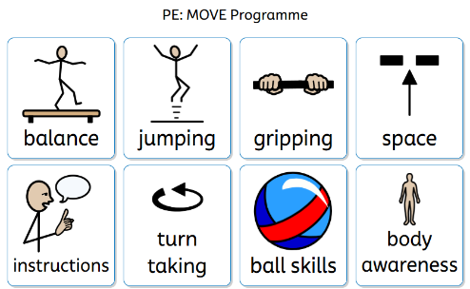
 |  |  | General Information
Reading books in school daily.
Books are changed on a Monday.

Spelling folder in school on a Monday.
Spelling tests and new spellings issued on a Monday.

PE – Friday

Outdoor learning: We use Curiosity Courtyard during COOL time so please have wellies and a puddlesuit in school if possible.

