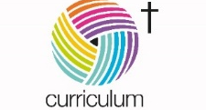

Lower Heath CE Primary School
Cycle A – Reception – Spring – Where the Wild Things Are
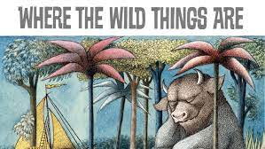

Communication and Language | Personal, Social and Emotional Development | Physical Development | Literacy (cross-curricular)
Pupils will be learning to:  - Use new vocabulary through the day.  - Articulate their ideas and thoughts in well-formed sentences  - Describe events in some detail  - Listen to and talk about stories to build familiarity and understanding.  - Listen to and talk about selected non-fiction to develop a deep familiarity with new knowledge and vocabulary  - Connect one idea or action to another using a range of connectives  - Learn rhymes, poems and songs to perform to an audience | Pupils will be learning to:  - Take on challenges  - Listen to and follow instructions.  R.E.  Pupils will be learning:  - why some places are special  - what makes the world special | To develop their fine and gross motor skills, children will be participating in Kinetic Letter activities, Dough Disco and have regular access to outdoor provision. They will also participate in weekly PE sessions and outdoor learning in our Allwood World. They will be focusing on developing their core strength along with throwing and catching skills. | Pupils will be experiencing a variety of adventure tales, traditional tales and adventures from the past through Drawing Club. They will be learning to write short labels/captions and simple sentence(s) with phonically plausible spellings; leaving spaces; using some capital letters and full stops  Phonics  - They will be learning to read during phonics using the Letters and Sounds programme. During this term, they will be focusing on Phase 3 sounds (ai, ee, igh, oa, oo, ar, or, ur, ow, oi, ear, air, er)  - Tricky words (was, you, they, my, by, all, are, sure, pure)  - Sound and blend letters to develop reading using phonics
Maths (cross-curricular) | Understanding the World | Expressive Arts and Design | Learning outdoors
Pupils will  - explore numbers to 10 including number bonds to 10  - addition and subtraction to 10  - exploring patterns  - measuring using length, height and weight | Science  Pupils will:  - learn about insects and animals  - learn about where their food comes from  R.E.  Pupils will:  - learn about our natural world  - learn about the Easter story | Pupils will:  - Explore sound, music and movement.  - Develop weaving and threading techniques  - Learn about Easter and create a hanging Easter decoration  - Learn about painting and colour mixing. | Children will:  - Learn about the changing seasons of Autumn, Winter and Spring; exploring change, colours, shapes and scents  - Identify different weather types and associated clothing.  - Create nature catchers  - Use their senses to for a variety of science experiments will focus on the different senses.

