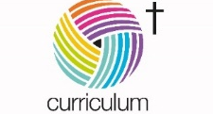

Lower Heath CE Primary School
Cycle A – EYFS – Summer – Planes, Trains and Automobiles
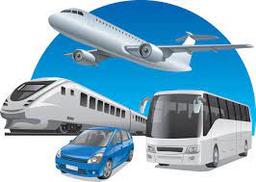

Communication and Language | Personal, Social and Emotional Development | Physical Development | Literacy (cross-curricular)
Pupils will be learning to:  - Listen to longer stories  - Follow 2 part instructions  - Answer why questions  - Speak in longer sentences  - Retell simple events  - Express a point of view  - Develop confidence in conversations  - Use talk to organise play | Pupils will:  - Work together with wheeled toys  - Share roles in transport play  - Prepare for change eg transition to Reception  - Play team games to build co-operation and reduce rough play  - Begin to identify and manage their own feelings  - Follow rules with fewer adult reminders  - Begin to wait for what they want and take turns  - Continue to develop respectful relationships  - Develop increasing empathy towards others | To develop their fine and gross motor skills, children will be participating in Kinetic Letter activities, Dough Disco and have regular access to outdoor provision. They will also practise their cutting and drawing skills.  In PE they will participate in obstacle courses with bridges and tunnels. They will also prepare for and participate in sports day activities. | - Pupils will be experiencing a variety of adventure tales, traditional tales and adventures from the past through Storydough.  Phonics  Children will be learning the nursery rhymes Down at the Station, Row Row Row, A Sailor went to sea, The Wheels on the bus, The Grand Old Duke of York and 1,2 buckle my shoe. They will also:  - Begin to listen carefully and show awareness of sounds in the environment  - Identify and talk about environmental sounds  - Recognise some letters and hear initial sounds in words  - Explore and identify sounds made by musical instruments and objects  - Join in with repetitive rhymes and songs.
Maths (cross-curricular) | Understanding the World | Expressive Arts and Design | Learning outdoors Understanding the World
Pupils will be learning about:  - Sequencing  - Positional language  - More and fewer  - 2D and 3D shapes  - Numbers to 5  - What comes before and after a number. | Children will be learning about:  - Floating and sinking  - Different types of transport  - People who help us eg pilot, bus driver, mechanic  - Different holiday environments eg beach, city, countryside | Children will be:  - Making junk modelling vehicles  - Building garages and airports using blocks  - Creating holiday art using watercolours  - Role playing travel agents and airports  - Using untuned instruments to create transport sounds and music | Children will learn about:  - the four seasons; exploring change, colours, shapes and scents.  - their senses  - using ride-on vehicles to explore forces  - floating and sinking

